CHAPTER 1
INTRODUCTION
1.1 OVERVIEW OF THE PROJECT
The problem is to extract the text in to contacts from the image, which may be from the gallery or may be through direct capture from mobile. The user can get the text and numbers in their particular fields convenient to store in phone. The user can use QR reader for scanning and saving contact.
1.2 LITERATURE SURVEY
Mobile Image Processing on the Google Phone with the Android Operating System by Michael T. Wells, This report analyzes the computation time of several common image processing routines on the HTC G1, also known as the Google Phone released in October 2008 as the first official hardware platform with the Android Operating System. Image processing on mobile phones is a new and exciting field with many challenges due to limited hardware and connectivity. Phones with cameras, powerful CPUs, and memory storage are becoming increasingly common. The need for benchmarking basic image processing routines such as: addition, convolution, thresholding and edge detection is important forcomparison of systems. With this information developers and researchers can design complex computer vision and image processing applications while being aware of the current state of the art limitations and bottlenecks on mobile phones.
Image Acquisition refers to the capturing of image data by a particular sensor or data repository. Once the image data is acquired, Pre-Processing often includes rendering the acquired data to a format that can be handled by a set of algorithms for Feature Extraction that transform subimage data to information which are often in turn maintained over time to provide temporal information. There are many software applications that focus on Acquisition and Pre-Processing primarily. These include applications that perform image editing and enhancement such as Adobe Photoshop. The goal of this project is to focus on Image Acquisition and Pre-Processing through implementing image addition, convolution, thresholding and edge detection on the HTC G1 mobile phone using the available Software Development Kit (SDK). Once these image processing routines are implemented the time it takes to perform these operations will be measured on various sample images (see Results and Appendix). Through this effort to quantify processing times for common routines in Image Processing, this information can be used to make decisions on the feasibility of implementing Feature Extraction and Tracking applications.
The Android operating system is preferable for benchmarking due to its recent growth in popularity with varying hardware manufactures e.g. HTC, Motorola, and Samsung. The Android operating system is supported and a part of the Open Handset Alliance. This alliance positions key manufacturers, cellular providers and the Android operating system in a collaborative environment which has caused large growth since October 2008 when the first Android mobile phone was released. Using the HTC G1 as the hardware for testing is advantageous because it is the first phone that was officially released with the Android operating system and is therefore a good platform to benchmark and begin developing image processing applications. The capabilities for this hardware include still images at a resolution of 1536 x 2048. By benchmarking key processing functions in Acquisition and Pre-Processing the design of omplex image processing and computer vision applications can be designed with this information in mind.
The particular challenges when implementing on the HTC G1 with the Android OS include architecting software and optimizing code for a. Google provides most of the documentation needed to development software applications on their developer web page , as well as forums to discuss your challenges and problems. Documentation and online tutorials are becoming increasingly more common as more developers begin to learn the ins and outs while coding in the Android Operating System.
Image Acquisition and Pre-Processing and the goal of the application is to acquire and decode images to byte data that can be processed. The software must measure the processing time of processing an individual image independent of decoding the image and displaying it. The image processing library was used for its image decoding functions contained in the class.One static instance for the current acquired image, another holds the previous image for the undo operation and the final image is for the add function. The more way doing this would be to maintain only the raw data for one image in memory and store the others in a file.The extracted text from the image compared on regx.
1.3 PROPOSED SYSTEM
In our project we extract text from an image and save to contact. Browsing the image files from gallery as well as camera will helpful to choose the image source and also selection of image for scanning process. UI is very user friendly.
User provided with an option for qr reader which takes qr images through camera and recognize the image and extract the text fields accordingly.The extracted text,numbers will automatically store in a digital format in user’s phone contacts.This may help the user to store all contact information digitally and never be lost.
1.3.1 ADVANTAGES OF THE PROPOSED SYSTEM

- It extracts the text from an image.
- It performs regx on the extracted text.
- It also displays the text and number in their particular field.
- It provides one click contact save.
- It provides facility to QR reader.

1.4 ANDROID PLATFORM ARCHITECTURE

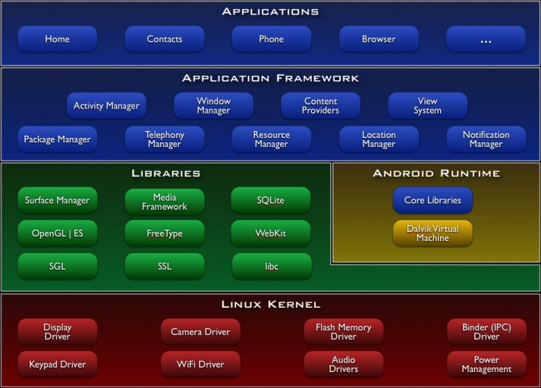
Fig 1.1 Android Architecture

1.4.1 APPLICATION
Android will ship with a set of core applications including an email client, SMS program, calendar, maps, browser, contacts, and others. All applications are written using the Java programming language.
1.4.2 APPLICATION FRAMEWORK
By providing an open development platform, Android offers developers the ability to build extremely rich and innovative applications. Developers are free to take advantage of the device hardware, access location information, run background services, set alarms, add notifications to the status bar, and much, much more.
Developers have full access to the same framework APIs used by the core applications. The application architecture is designed to simplify the reuse of components; any application can publish its capabilities and any other application may then make use of those capabilities (subject to security constraints enforced by the framework). This same mechanism allows components to be replaced by the user.
Underlying all applications is a set of services and systems, including:
- A rich and extensible set of Views that can be used to build an application, including lists, grids, text boxes, buttons, and even an embeddable web browser.
- Content Providers that enable applications to access data from other applications (such as Contacts), or to share their own data.

1.4.3 LIBRARIES
Android includes a set of C/C++ libraries used by various components of the Android system. These capabilities are exposed to developers through the Android application framework. Some of the core libraries are listed below:
- System C library - a BSD-derived implementation of the standard C system library (libc), tuned for embedded Linux-based devices
- Media Libraries - based on PacketVideo's OpenCORE; the libraries support playback and recording of many popular audio and video formats, as well as static image files, including MPEG3, H.263, MP3, AAC, AMR, JPG, and PNG
- Surface Manager - manages access to the display subsystem and seamlessly composites 2D and 3D graphic layers from multiple applications
- Lib Web Core - a modern web browser engine which powers both the Android browser and an embeddable web view
- SGL - the underlying 2D graphics engine
- 3D libraries - an implementation based on OpenGL ES 1.0 APIs; the libraries use either hardware 3D acceleration (where available) or the included, highly optimized 3D software rasterizer
1.4.4 ANDROID RUNTIME
Android includes a set of core libraries that provides most of the functionality available in the core libraries of the Java programming language.
Every Android application runs in its own process, with its own instance of the Dalvik virtual machine. Dalvik has been written so that a device can run multiple VMs efficiently. The Dalvik VM executes files in the Dalvik Executable (.dex) format which is optimized for minimal memory footprint. The VM is register-based, and runs classes compiled by a Java language compiler that have been transformed into the .dex format by the included "dx" tool.
The Dalvik VM relies on the Linux kernel for underlying functionality such as threading and low-level memory management.
1.4.5 LINUX KERNEL
Android relies on Linux version 2.6 for core system services such as security, memory management, process management, network stack, and driver model. The kernel also acts as an abstraction layer between the hardware and the rest of the software stack.

1.5 REQUIREMENT SPECIFICATIONS
1.5.1 HARDWARE REQUIREMENTS
Processor : Pentium dual core
RAM : 1 GB
Hard Disk Drive : 80 GB
Monitor : 14” Color Monitor

1.5.2 SOFTWARE REQUIREMENTS
Front End/GUI : DroidDraw
Operating System : Windows 4 or Linux
Language : Java , XML
Softwares : Eclipse,jdk6.0.java.
Package : AndroidSDK,AVD manager,API

CHAPTER 2
DETAILED DESCRIPTION
2.1 MODULE DECOMPOSITION
- Image Capturing
- Text Cropping
- Image Scanning.
- Text Extraction
- One Click Contact Save.
2.2 MODULE DESCRIPTION
2.2.1 IMAGE CAPTURING
This module is used for getting the image from the user .The user have to choose the image source whether an image from Gallery or Camera. In the Gallery option, this module opens the images present in the gallery .In this module, it categories the images that are present in the gallery such as received files, camera files, bluetooth files. In case of Camera option this module opens the camera and provides an option to take picture and saves the captured picture in memory card. This module sends the captured image or user selected image to Cropping process This module will be the first module of this project.
QR image is scanned using phone camera and by zxing it read the images and the text is process accordingly.

2.2.2 TEXT CROPPING
This module is used for cropping the text from an image. It receives the captured image or user selected image as input .It provides the tool to crop the text from an image. The user is requested to crop the text area in an image. It saves the cropped image as file and sends the file for the Scanning process. This module provides the cropped image as output.
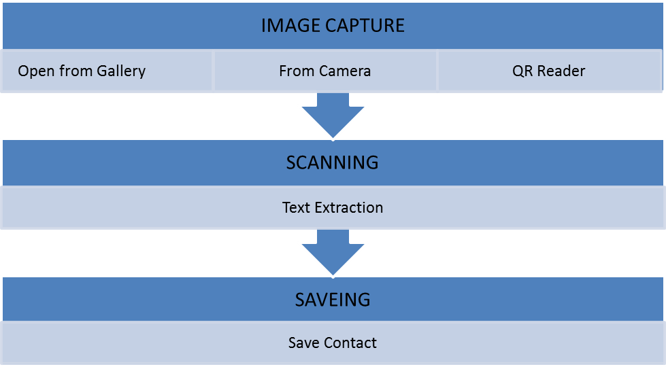
Fig 2.1 Major Modules
2.2.3 IMAGE SCANNING
This module helps in getting the cropped image as an input. In this module, a cropped image is scanned by the methods in OCR tesstwo libraries. The user is requested to select the language before scanning an image. If the user doesn't select the language or wrong selection of language in an image then it won't scan the cropped image. If the user selects the language correctly, then it will scan the image for the text.
In this method user provide an option for selecting image source which may be a JPEG image or QR image ,QR image will be scanned using zing libraries provided in application where as JPEG image will be scanned using tesseract and leptonica.Leptonica implements image scalling ,rotation,shearing and other image processing .Tesseract will perform OCR (Optical Character Recognization) in offline mode
2.2.4 TEXT EXTRACTION
This module is used for extraction of text from an image. In this module, text in an image is extracted by the trained data in assests. This module uses the trained data to identify the texts in an image. It prepares the trained data and preprocess the cropped image .It performs the character recognition using Tesseract engine and provides the extracted text as output. This module displays the cropped image and also extracted text from that cropped image to the user.
Text extraction by QR images are also possible by using reader button included in application.The text extracted will separate in to fields such as number,name,address and provide an option for user to edit the text if changes and edited text will be saved automatically.
2.2.5 ONE CLICK CONTACT SAVE
This module will work for saving the text and number. After the text extraction from an image we have to provide the text for saving to phone contact. This module use regular expressions to extract text based on the name,number,emaild,address. It reads the extracted text as input and save the text into contact and also provide option for QR reader and save text to contact.
2.3 SYSTEM ANALYSIS
- It needs GPRS to give the meaning of the text.
- If we need to extract text from an image .we have to do the following .
1. We have to crop the text from an image.
2. We have to option for QR.
- To save the text which is extracted from an image we need to click the save button.
- To use the QR we need to click the QR button, after text are extracted click save button.
2.3.1 ADVANTAGES
1. It extracts the text as well as provides option to edit text .
2. It stores digitally your contacts.
3. It also use QR and save the text.
2.3.2 DISADVANTAGES
1. Clear image is required to obtain text.
2. Cannot run under versions below Android 2.3 .
2.4 SOFTWARE DESCRIPTION
2.4.1 JAVA
It is a Platform Independent. Java is an object-oriented programming language developed initially by James Gosling and colleagues at Sun Microsystems.
The following are some of the features which have made Java one of the most popular among the various available programming languages.

- Simple
Java was developed by taking the best points from other programming languages, primarily C and C++. Since Java is primarily a derivative of C++ which most programmers are conversant with, it implies that Java has a familiar feel rendering it easy to use.
- Object Oriented
Even though Java has the look and feel of C++, it is a wholly independent language which has been designed to be object-oriented from the ground up. In object-oriented programming (OOP), data is treated as objects to which methods are applied.
- Distributed
Commonly used Internet protocols such as HTTP and FTP as well as calls for network access are built into Java..
- Interpreted
When Java code is compiled, the compiler outputs the Java Bytecode which is an executable for the Java Virtual Machine. The bytecode is then run through a Java interpreter on any given platform that has the interpreter ported to it.
- Robust
Java compels the programmer to be thorough. It carries out type checking at both compile and runtime making sure that every data structure has been clearly defined and typed. Java manages memory automatically by using an automatic garbage collector.

- Secure
The Java language has built-in capabilities to ensure that violations of security do not occur. somewhere on the Internet. Trojan horses or worms which can invade the local computer system and wreak havoc on it.
2.4.2 TESSERACT
Tesseract is a free software optical character recognition engine for various operating systems.
Tesseract is considered one of the most accurate free software OCR engines currently available.
Tesseract is suitable for use as a backend,and can be used for more complicated OCR tasks including layout analysis by using a frontend such as OCRplus.
A lot of the code was written in C, and then some more was written in C++. Since then all the code has been converted to at least compile with a C++ compiler.
2.4.3 LEPTONICA
Leptonica is configured to handle image I/O using these external libraries: libjpeg, libtiff, libpng, libz, libgif, libwebp.
Leptonica also allows image I/O with bmp and pnm formats, for which we provide the serializers (encoders and decoders). It also gives output drivers for wrapping images in PostScript, which in turn use tiffg3, jpeg and png encoding.
There is a sortable and searchable categorized list of all the functions available in Leptonica. There are also summaries of the files in the src and prog directories with short descriptions of each file.
Leptonica implements image scaling, rotation, shearing and other image processing. Featured operations are masking, blending ,enhancement, arithmetic operations, image transformation combining changes in scale and pixel depth, seed fill , transformation(scaling, translation, rotation, shear)on images of arbitrary pixel depth.
2.4.4 JPEG LIB
The IJG JPEG library provides C code to read and write JPEG-compressed image files. The surrounding application program receives or supplies image data a scanline at a time, using a straightforward uncompressed image format. All details of color conversion and other preprocessing/postprocessing can be handled by the library.
The library includes a substantial amount of code that is not covered by the JPEG standard but is necessary for typical applications of JPEG. These functions preprocess the image before JPEG compression or postprocess it after decompression. They include colors pace conversion, downsampling/upsampling, and color quantization. The application indirectly selects use of this code by specifying the format in which it wishes to supply or receive image data. For example, if colormapped output is requested, then the decompression library automatically invokes color quantization.
A wide range of quality vs. speed tradeoffs are possible in JPEG processing, and even more so in decompression postprocessing. The decompression library provides multiple implementations that cover most of the useful tradeoffs, ranging from very-high-quality down to fast-preview operation. On the compression side we have generally not provided low-quality choices, since compression is normally less time-critical. It should be understood that the low-quality modes may not meet the JPEG standard's accuracy requirements; nonetheless, they are useful for viewers.
2.4.5 ECLIPSE
The Eclipse Platform uses plug-ins to provide all functionality within and on top of the runtime system, in contrast to some other applications, in which functionality is hard coded. The Eclipse Platform's runtime system is based on Equinox, an implementation of the OSGi core framework specification.
This plug-in mechanism is a lightweight sofwate componentry framework. In addition to allowing the Eclipse Platform to be extended using other programming languages such as C and Python, the plug-in framework allows the Eclipse Platform to work with typesetting languages like LaTex, networking applications such as telnet and database management systems. The plug-in architecture supports writing any desired extension to the environment, such as for configuration Management. Java and CVSsupport is provided in the Eclipse SDK, with support for other version control systems provided by third-party plug-ins.
With the exception of a small run-time kernel, everything in Eclipse is a plug-in. This means that every plug-in developed integrates with Eclipse in exactly the same way as other plug-ins; in this respect, all features are "created equal".Eclipse provides plug-ins for a wide variety of features, some of which are through third parties using both free and commercial models. Examples of plug-ins include a UML plug-in for Sequence and other UML diagrams, a plug-in for DB Explorer, and many others.
The Eclipse SDK includes the Eclipse Java development tools (JDT), offering an IDE with a built-in incremental Java compiler and a full model of the Java source files. This allows for advanced refactoring techniques and code analysis. The IDE also makes use of a workspace, in this case a set of metadata over a flat filespace allowing external file modifications as long as the corresponding workspace "resource" is refreshed afterwards.
2.4.6 ADT FOR ECLIPSE
Android Development Tools (ADT) is a plugin for the Eclipse IDE that is designed to give a powerful, integrated environment in which to build Android applications.
ADT extends the capabilities of Eclipse to let us quickly set up new Android projects, create an application UI, add packages based on the Android Framework API, debug our applications using the Android SDK tools, and even export signed (or unsigned) .apk files in order to distribute our application.
Developing in Eclipse with ADT is highly recommended and is the fastest way to get started. With the guided project setup it provides, as well as tools integration, custom XML editors, and debug output pane, ADT gives us an incredible boost in developing Android applications. The plug-in architecture supports writing any desired extension to the environment, such as for configuration Management. Java and CVS support is provided in the Eclipse SDK, with support for other version control systems provided by third-party plug-ins.
2.4.7 DEPENDENCIES
- Java 1.6 or higher is required for ADT 14.0.0.
- Eclipse Helios (Version 3.6.2) or higher is required for ADT 14.0.0.

2.4.8 ANDROID SDK
A software development kit that enables developers to create applications for the Android platform. The Android SDK includes sample projects with source code, development tools, an emulator, and required libraries to build Android applications. Applications are written using the java programming language and run on Dalvik, a custom virtual machine designed for embedded use which runs on top of a Linux kernel.
2.4.9 ANDROID AVD MANAGER
The AVD Manager is an easy to use user interface to manage your AVD (Android Virtual Device) configurations. An AVD is a device configuration for the Android emulator that allows you to model different configurations of Android-powered devices. When you start the AVD Manager in Eclipse or run the android tool on the command line

CHAPTER 3
SYSTEM DESIGN
3.1 SEQUENCE DIAGRAM
A sequence diagram in unified modeling language is a kind of interaction diagram that shows how processes operate with one another and in what order. It is a construct of a Message Sequence Chart. Sequence diagrams are sometimes called Event-trace diagrams, event scenarios, and timing diagrams. A sequence diagram shows, as parallel vertical lines (lifelines), different processes or objects that live simultaneously, and, as horizontal arrows, the messages exchanged between them, in the order in which they occur.
In the below sequence diagram, the order of execution of the application is depicted. Initially after opening the application the user needs to select the source of the image containing the text and the image is fed to the main program for further processing. Now the main thread accesses the image and then retrieves the text from image. Now for the QR click option QR and save the text extacted.Text is analyzed and the corresponding text and numbers displays in their corresponding fields.
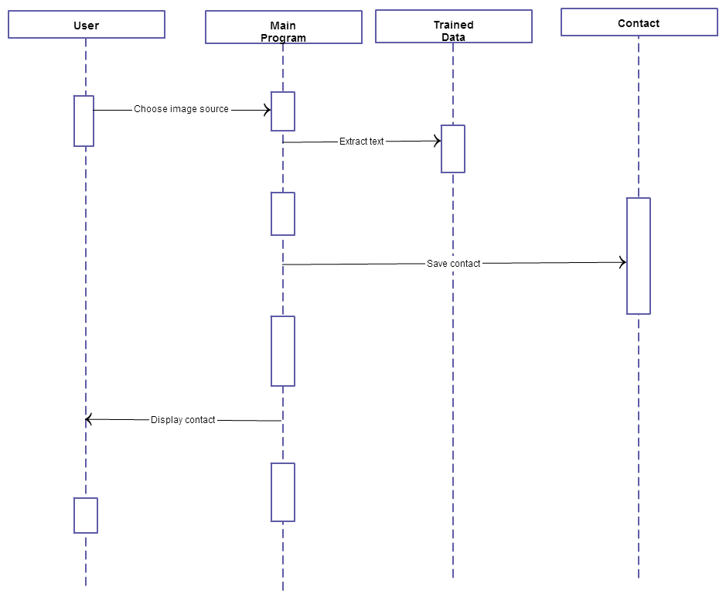

Fig 3.1 Sequence Diagram

3.2 COLLABORATION DIAGRAM
Collaboration diagrams belong to a group of UML diagrams called Interaction Diagrams. Collaboration diagrams, like Sequence Diagrams, show how objects interact over the course of time. However, instead of showing the sequence of events by the layout on the diagram, collaboration diagrams show the sequence by numbering the messages on the diagram. This makes it easier to show how the objects are linked together, but harder to see the sequence at a glance.

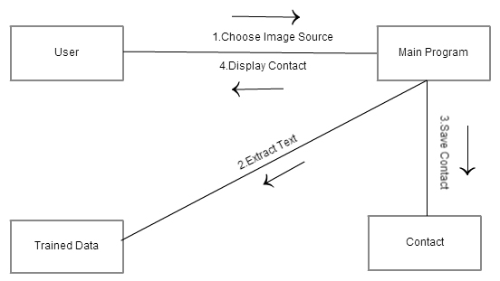
Fig 3.2 Collaboration Diagram

Unlike the sequence diagram, it does not show the sequence of execution of the application. As the name implies, interaction diagram shows the various behavior and relationship between the objects of the system. The numbers over arrows show the order of interactions among the objects. First, the image source is selected and at last the translated text is obtained .These interactions are among user and the main program. Similarly, there another option for QR. These interactions are done for text extraction.
3.3 DATAFLOW DIAGRAM
A data flow diagram (DFD) is a graphical representation of the "flow" of data through an information system, modeling its process aspects. Often they are a preliminary step used to create an overview of the system.
DFDs can also be used for the visualization of data processing (structured design).A DFD shows what kinds of data will be input to and output from the system, where the data will come from and go to, and where the data will be stored. It does not show information about the timing of processes, or information about whether processes will operate in sequence or in parallel.
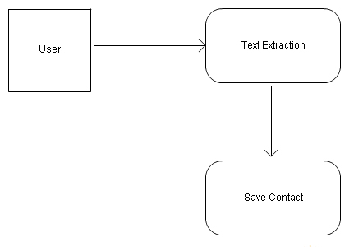
Fig 3.3.1 Level 0 DFD
The above diagram shows the flow of data i.e inputs from the user and internal communications between the various modules of the project. The image source is selected from the mobile SD card or through direct capture from mobile and is given as input to the main application thread.
Then the image is cropped to select the appropriate text in it and if QR can also be selected passed as input to the text extraction module. The extracted text displays in corresponding fields.One click contact save button is used.
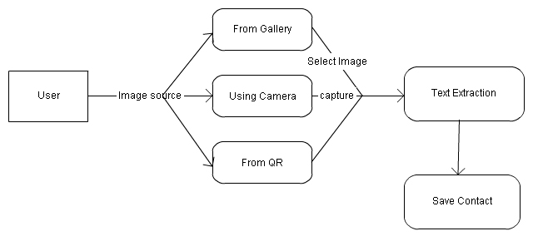 Fig 3.3.2 Level 1 DFD
User selects an image source from gallery,qr or capture an image by using phone’s camera,the text in an image is cropped and extracted to save in contact digitally.User provide an option to edit text which has extracted from image.The contact stored is displayed to user through phone.
Image source is from user’s option may be from qr, gallery and by using camera, the image choosen is cropped and text is extracted through scanning option and the save contact will save those text to phone’s contact in digital format. User provide an option for editing the extracted text for convinient use and save.

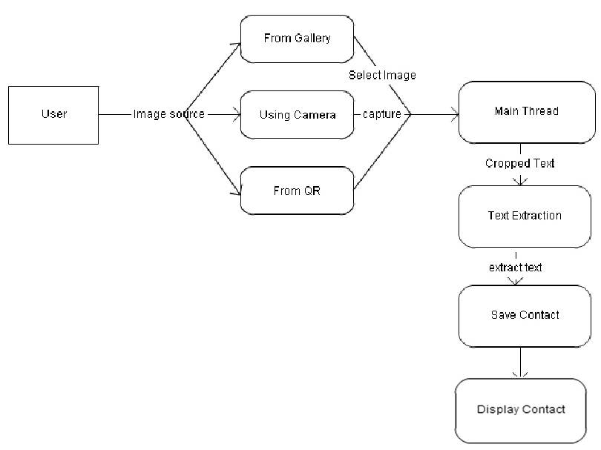
Fig 3.3.2 Level 2 DFD
Main thread has the image to be cropped and text extraction will extract those selected text and save to phone’s contact and display to user. The contact stored in a digital format convinient for user to copy, send and edit contact information and so on.
3.4 USE CASE DIAGRAM
Use Case diagram are behavior diagrams used to describe a set of actions (use cases) that some system or systems (subject) should or can perform in collaboration with one or more external users of the system (actors). Each use case should provide some observable and valuable result to the actors or other stakeholders of the system. Use case diagrams are used to specify:
- (external) requirements on a subject, required usages of a system - to capture what a system under construction is supposed to do;
- the functionality offered by a subject – what system can do;
- requirements the specified subject poses on its environment - by defining how environment should interact with the subject so that it will be able to perform its services.

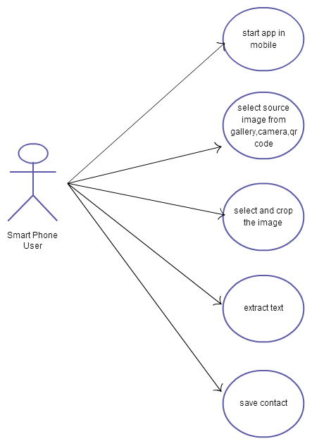
Fig 3.4 Use Case Diagram

3.5 ACTIVITY DIAGRAM
Activity diagrams are graphical representations of workflows of stepwise activities and actions with support for choice, iteration and concurrency. In the Unified Modeling Language, activity diagrams can be used to describe the business and operational step-by-step workflows of components in a system. An activity diagram shows the overall flow of control.
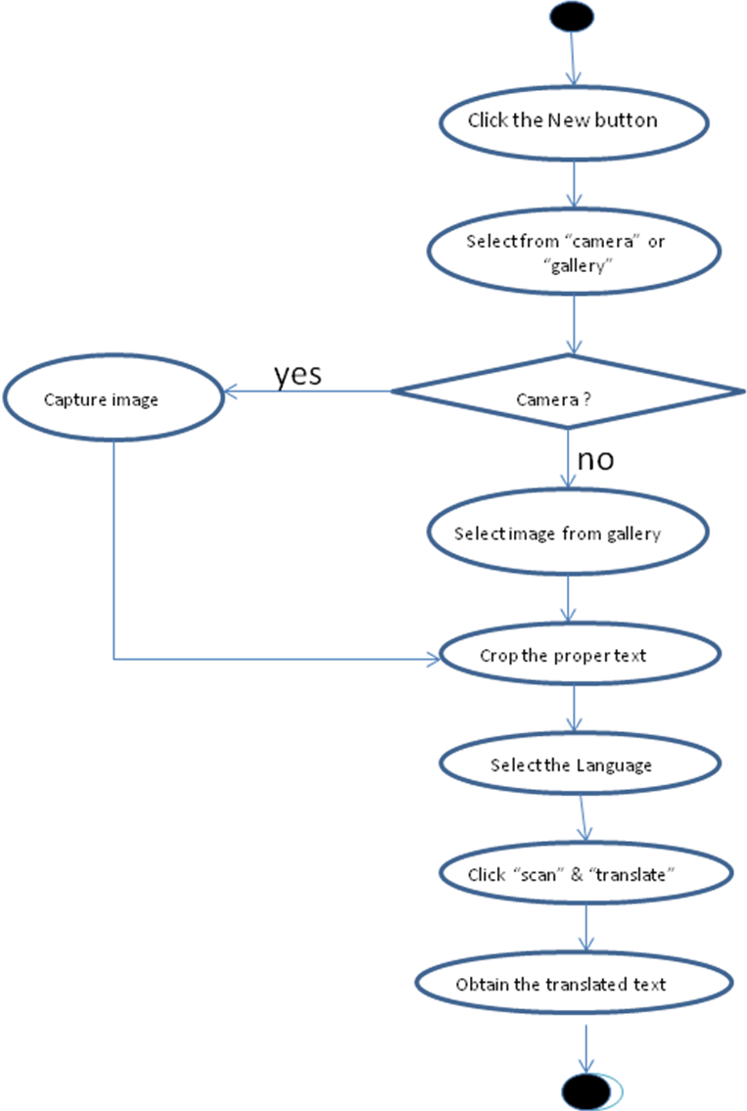
Fig 3.5 Activity Diagram
Activity diagrams help us to understand the system by depicting the various activities involved and the order in which they run. The various components and their corresponding functionalities can be understood from the Activity diagrams. In the above diagram, the first activity is selecting the type of source of the input image. Either it’s from the SD card or direct capture using the mobile’s camera.
Then the text in the image needs to be cropped appropriately and the source language is mentioned. Now the text needs to be extracted from the cropped image and then it is fed as input to the one click save module of the system in order to get the final output.
3.6 CLASS DIAGRAM
The class diagram is the main building block of object oriented modelling. It is used both for general conceptual modelling of the systematics of the application, and for detailed modelling translating the models into programming code. In the class diagram these classes are represented with boxes which contain three parts:
- The upper part holds the name of the class
- The middle part contains the attributes of the class
- The bottom part gives the methods or operations the class can take or undertake
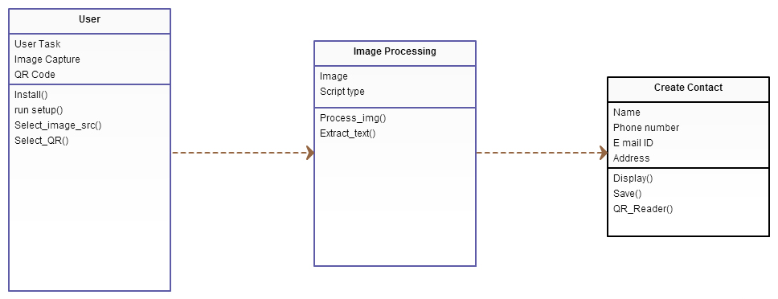
Fig 3.6 Class diagram
Class diagrams in general is useful to know the overall design of the project. It shows the various components or modules involved in the project. It gives the information for every class like the attributes and functions. It also shows the associations between these modules. First class denotes the user who is operating the application. The attributes are his technical knowledge and major function of the user is to install the application, read the help options and give appropriate inputs accordingly.
Similarly in the Image processing module the attributes are the types of image formats acceptable for processing and the function is extracting the text from the image then the text in the image is cropped. At last in translation module attributes are the various data fields available for saving to phone contacts.
3.7 COMPONENT DIAGRAM
The component diagram's main purpose is to show the structural relationships between the components of a system. In UML, a component represented implementation items, such as files and executables. The idea is that you can easily reuse and/or substitute a different component implementation in your designs because a component encapsulates behavior and implements specified interfaces.

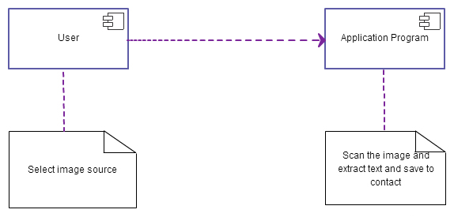
Fig 3.7 Component Diagram
In this project, the major components involved are the user and the application program. Here the user’s job is to select the image source either from the mobile’s gallery or through direct capture from mobile. This application program assess the given input image and translate the text.

CHAPTER 4
IMPLEMENTATION AND TEST PLAN
4.1 IMPLEMENTATION
This project is mainly used to extract the text from an image and transliterate the extracted text to the user with also feature to translate the extracted text.
4.2 TESTING
Software testing is an investigation conducted to provide stakeholders with information about the quality of the product or service under test. Software testing also provides an objective, independent view of the software to allow the business to appreciate and understand the risks of software implementation. Test techniques include, but are not limited to, the process of executing a program or application with the intent of finding software bugs.
Software testing can also be stated as the process of validating and verifying that a software program/application/product:
- meets the business and technical requirements that guided its design and development;
- works as expected; and
- Can be implemented with the same characteristics.
4.2.1 UNIT TESTING
Unit testing is a development procedure where programmers create tests as they develop software.

Test case No | Test case | Input | Output expected | Output obtained | PASS/FAIL
1. | Check for camera working or not | Click camera buttom | Opens camera and ready for capture | Opens camera and ready for capture | PASS
2. | Check for image storage | Click capture button on mobile | Image is stored for further processing | Image is stored for further processing | PASS
3. | Image access from SD card | Select from gallery button and choose an image from gallery | Image is opened for cropping | Image is opened for cropping | PASS

4.1 Unit Testing of Image Capture
The tests are simple short tests that test functionality of a particular unit or module of their code, such as a class or function. In this project all the modules are tested individually with required inputs and it works clean.

Test case No | Test case | Input | Output expected | Output obtained | PASS/FAIL
1. | Selection of proper text | Scroll select the text in image | Selected part is highlighted in the image | Selected part is highlighted in the image | PASS
2. | Cropping image | Click crop button | Highlighted  Part is cropped and saved as new image | Highlighted  Part is cropped and saved as new image | PASS

4.2 Unit Testing of Cropping

Test case No | Test case | Input | Output expected | Output obtained | PASS/FAIL
1. | Well known fonts in printed format | 10 images with proper cropping of required portion | 10/10 | 10/10 | PASS  (Accuracy:100%)
2. | Images of handwritten text | 5 images with proper cropping of required portion | 5/5 | 5/5 | PASS  (Accuracy:60%)
3. | Images with complex backgrounds | 5 images with proper cropping of required portion | 5/5 | 5/5 | FAIL  (Accuracy:10%)

4.3 Unit Testing of Image Scanning

4.2.2 SYSTEM TESTING
System testing of software or hardware is testing conducted on a complete, integrated system to evaluate the system's compliance with its specified requirements. System testing falls within the scope of black box testing, and as such, should require no knowledge of the inner design of the code or logic. In this project all the relevant inputs are given and tested. It works clean.
4.2.3 INTEGRATION TESTING
Integration testing is the phase in software testing in which individual software modules are combined and tested as a group. It occurs after unit testing and before system testing. Integration testing takes as its input modules that have been unit tested, groups them in larger aggregates, applies tests defined in an integration test plan to those aggregates, and delivers as its output the integrated system ready for system testing. In this project all the modules are combined together and tested with required inputs. It works clean.

Test case No | Test case | Input | Output expected | Output obtained | PASS/FAIL
1. | To test captured image is accessible for cropping | Click from camera and Click capture | Captured image displayed with option to crop | Captured image displayed with option to crop | PASS
2. | Integration between cropping and scanning | Click crop button after highlighting required part | Cropped image is displayed with option to scan | Cropped image is displayed with option to scan | PASS
3. | Integration between scaning and extraction | Click scan and Click extract button | Extracted text is displayed option to save | Extracted text is displayed option to save | PASS

4.4 Integration Testing

CHAPTER 5
CONCLUSION AND FUTURE ENHANCEMENT
5.1 CONCLUSION
The goal of this project is to provide the user to save contact information digitally in phone’s address book .This application works on smart phones working on Android platform (version 2.3 and above ). This application helps the user to use both image processing and QR to extract text in an image and one click contact save. For extracting text does not require the web access, which is one of the significant advantages of this project.
5.2 FUTURE ENHANCEMENT
In future the project can be enhanced to many languages since it is now only facilitating the English. While in the current project we do QR reader and save the extracted text to contact.In future, the application may be provide with an option to read QR code image and do extraction on it. Also enhance further to work almost in all versions of Android OS unlike now which runs only in versions 4.1 and above.

APPENDIX A
Source Code
CAMERA.JAVA
package com.example.camcontact;
import java.io.File;
import com.example.camcontact.sricrop.*;
import java.io.FileOutputStream;
import java.util.Calendar;
import android.app.Activity;
import android.app.ProgressDialog;
import android.graphics.Bitmap;
import android.graphics.BitmapFactory;
import android.graphics.PixelFormat;
import android.graphics.PointF;
import android.hardware.Camera;
import android.media.MediaScannerConnection;
import android.os.Bundle;
import android.os.Environment;
import android.view.Display;
import android.view.KeyEvent;
import android.view.SurfaceHolder;
import android.view.SurfaceView;
import android.widget.ImageView;;
public class camera extends Activity {
private SurfaceView preview=null;
private SurfaceHolder previewHolder=null;
private Camera camera=null;
private boolean inPreview=false;
ImageView image;
Bitmap bmp,itembmp;
static Bitmap mutableBitmap;
PointF start = new PointF();
PointF mid = new PointF();
float oldDist = 1f;
File imageFileName = null;
File imageFileFolder = null;
private MediaScannerConnection msConn;
Display d;
int screenhgt,screenwdh;
ProgressDialog dialog;
@Override
public void onCreate(Bundle savedInstanceState) {
super.onCreate(savedInstanceState);
setContentView(R.layout.camera);
image=(ImageView)findViewById(R.id.image);
preview=(SurfaceView)findViewById(R.id.surface);
setRequestedOrientation(ActivityInfo.SCREEN_ORIENTATION_LANDSCAPE)
previewHolder=preview.getHolder();
previewHolder.addCallback(surfaceCallback);
previewHolder.getSurface();
previewHolder.setType(SurfaceHolder.SURFACE_TYPE_PUSH_BUFFERS);
.getDefaultDisplay().getWidth(), getWindow().getWindowManager()
getDefaultDisplay().getHeight());}
camera.release();
camera=null;
inPreview=false;
super.onPause();
}
SurfaceHolder.Callback SurfaceHolder.Callback(){
public void surfaceCreated(SurfaceHolder holder) {
public void surfaceChanged(SurfaceHolder holder,
int format, int width,
int height) {
parameters.setPreviewSize(size.width, size.height);
parameters.setPictureFormat(PixelFormat.JPEG);
camera.setParameters(parameters);
camera.startPreview();
inPreview=true;
}
Camera.PictureCallback Camera.PictureCallback(){
public void onPictureTaken(final byte[] data, final Camera camera){
dialog=ProgressDialog.show(camera.this,"","Saving Photo");
new Thread(){
public void onPictureTake(byte[] data, Camera camera);
bmp = BitmapFactory.decodeByteArray(data, 0, data.length);
savePhoto(bmp);
dialog.dismiss();
@Override
protected String doInBackground(byte[]... jpeg) {
File File(Environment.getExternalStorageDirectory(),"photo.jpg");
if (photo.exists()){
photo.delete();
}
try {
FileOutputStream fos=new FileOutputStream(photo.getPath());
fos.write(jpeg[0]);
fos.close();
}
catch (java.io.IOException e) {
}
return(null);
}
public void savePhoto(Bitmap bmp)
{
imageFileFolder File(Environment.getExternalStorageDirectory(),"contact");
if(!imageFileFolder.exists()) {
imageFileFolder.mkdirs();
}
FileOutputStream out = null;
Calendar c = Calendar.getInstance();
String date = fromInt(c.get(Calendar.MONTH))
+ fromInt(c.get(Calendar.DAY_OF_MONTH))
+ fromInt(c.get(Calendar.YEAR))
+ fromInt(c.get(Calendar.HOUR_OF_DAY))
+ fromInt(c.get(Calendar.MINUTE))
+ fromInt(c.get(Calendar.SECOND));
String date1=date.toString();
out = new FileOutputStream(imageFileName);
bmp.compress(Bitmap.CompressFormat.JPEG, 100, out);
imageFileName.toString());
out = null;
public void onScanCompleted(String path, Uri uri)
{
msConn.disconnect();
});
msConn.connect();
Intent i=new Intent(camera.this,sricrop.class);
i.putExtra("filename", imageFileName);
i.putExtra("back", "camera");
startActivity(i);
}
public void onBack(){
camera.takePicture(null,null,photoCallback);
inPreview=false;
}
}
SCANNERIMAGE.JAVA
package com.example.cameracontact.sricrop;
import java.io.File;
import java.io.FileOutputStream;
import java.io.IOException;
import java.io.InputStream;
import java.io.OutputStream;
import android.app.Activity;
import android.app.ProgressDialog;
import android.content.Intent;
import android.content.res.AssetManager;
import android.graphics.Bitmap;
import android.graphics.BitmapFactory;
import android.graphics.Matrix;
import android.media.ExifInterface;
import android.os.Bundle;
import android.os.Environment;
import android.view.WindowManager;
import android.widget.Button;
import android.util.Log;
import com.googlecode.tesseract.android.TessBaseAPI;
public class Scannerimage extends Activity {
public static final String PACKAGE_NAME = "com.example.cameracontact";
public static final String DATA_PATH = Environment
.getExternalStorageDirectory().toString() + "/contact";
ProgressDialog dialog;
Button tbutton;
String sfile;
private static final String LOG_TAG = "Scannerimage.java";
@Override
public void onCreate(Bundle savedInstanceState) {
AssetManager assetManager = getAssets();
String[] files = null;
try {
files = assetManager.list("");
} catch (IOException e) {
Log.v(LOG_TAG, e.toString());
}
for(String filename : files) {
InputStream in = null;
OutputStream out = null;
try {
in = assetManager.open(filename);
File tesserfile=new File(DATA_PATH);
if(!tesserfile.exists()) {
tesserfile.mkdirs();
}
String tesspath=DATA_PATH+"/tessdata/";
File tessfile=new File(tesspath);
if(!tessfile.exists()) {
tessfile.mkdirs();
Log.v("tag", "data path created");
}
out = new FileOutputStream(tesspath + filename.replace(".mp3",""));
byte[] buffer = new byte[2048];
int read;
while((read = in.read(buffer)) != -1){
out.write(buffer,0,read);
}
in.close();
in = null;
out.flush();
out.close();
out = null;
} catch(Exception ie) {
Log.v(LOG_TAG, ie.toString());
}
}
super.onCreate(savedInstanceState);
getWindow().addFlags(WindowManager.LayoutParams.FLAG_FULLSCREEN);
imgtotext();
}
public void imgtotext() {
Bundle b=getIntent().getExtras();
String filename1=b.getString("filename");
sfile=b.getString("sfile");
final String LANG=language;
BitmapFactory.Options options=new BitmapFactory.Options();
options.inPreferredConfig=Bitmap.Config.ARGB_8888;
Bitmap bitmap=BitmapFactory.decodeFile(filename1,options);
try {
ExifInterface exif=new ExifInterface(filename1.toString());
int exifOrientation=exif.getAttributeInt(ExifInterface.TAG_ORIENTATION,ExifInterface.ORIENTATION_NORMAL);
Log.v(LOG_TAG,"Orient:"+exifOrientation);
int rotate=0;
switch(exifOrientation) {
case ExifInterface.ORIENTATION_ROTATE_90:
rotate=90;
break;
case ExifInterface.ORIENTATION_ROTATE_180:
rotate=180;
break;
case ExifInterface.ORIENTATION_ROTATE_270:
rotate=270;
break;
}
Log.v(LOG_TAG,"Rotation:"+rotate);
if(rotate!=0) {
int w=bitmap.getWidth();
int h=bitmap.getHeight();
Matrix mtx=new Matrix();
mtx.preRotate(rotate);
bitmap=Bitmap.createBitmap(bitmap, 0, 0,w,h,mtx,false);
bitmap = bitmap.copy(Bitmap.Config.ARGB_8888, true);
}
}
catch(IOException e) {
Log.e(LOG_TAG,"Rotate or coversion failed:"+e.toString());
}
Log.v(LOG_TAG,"Befor baseApi");
TessBaseAPI baseApi=new TessBaseAPI();
baseApi.setDebug(true);
baseApi.init(DATA_PATH,LANG);
baseApi.setImage(bitmap);
final String recognizedText=baseApi.getUTF8Text();
baseApi.end();
Log.v(LOG_TAG,"OCR Result:" + recognizedText);
Intent i=new Intent(this,display.class);
i.putExtra("retext", recognizedText);
i.putExtra("filename", filename1);
i.putExtra("sfile", sfile);
startActivity(i);
}
}

APPENDIX B
Screen Shots
- Click the Image Source
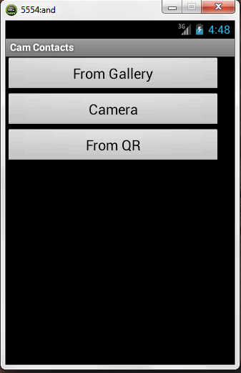
Fig B.1
When the user opens our application Fig B.1 shows the starting page of our application.User can choose the image source from gallery ,qr or capture image.

- Select from gallery,choose a Folder
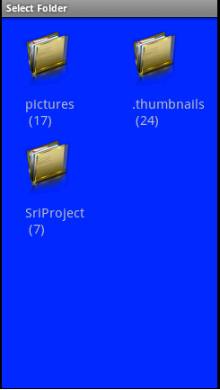
Fig B.2
Choose from gallery,,click the folder which contains image for text extraction ,a folder sriproject will create which as trained data files and the images captured by using camera.

- Select the image
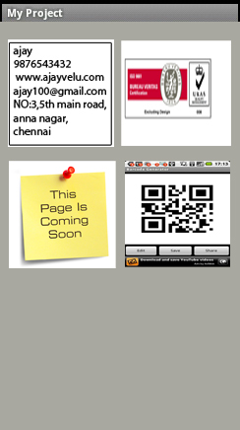
Fig B.3
Choose image for text extraction and crop the proper fields,after cropping the image the text extraction proceeds.By using QR the text directly copied to a separate fields.

- Text Extraction
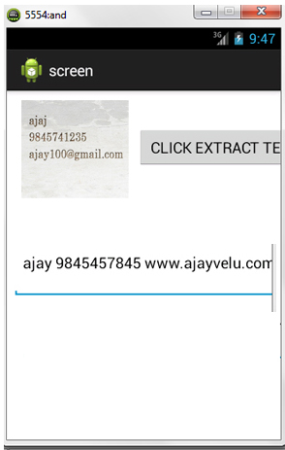
Fig B.4
Text extraction will extract the proper text such as name,email id,address,contact number and store it in to a field allowing user to edit the text.

- Saving to contact
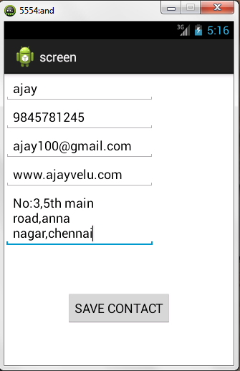
Fig B.5
Image is scanned using leptonica libraries and the extracted text is shown in the separate fields.click save button the text will be saved to contacts. User provide an option for editing amd save to contact.

- Take a snapshot of the image using camera
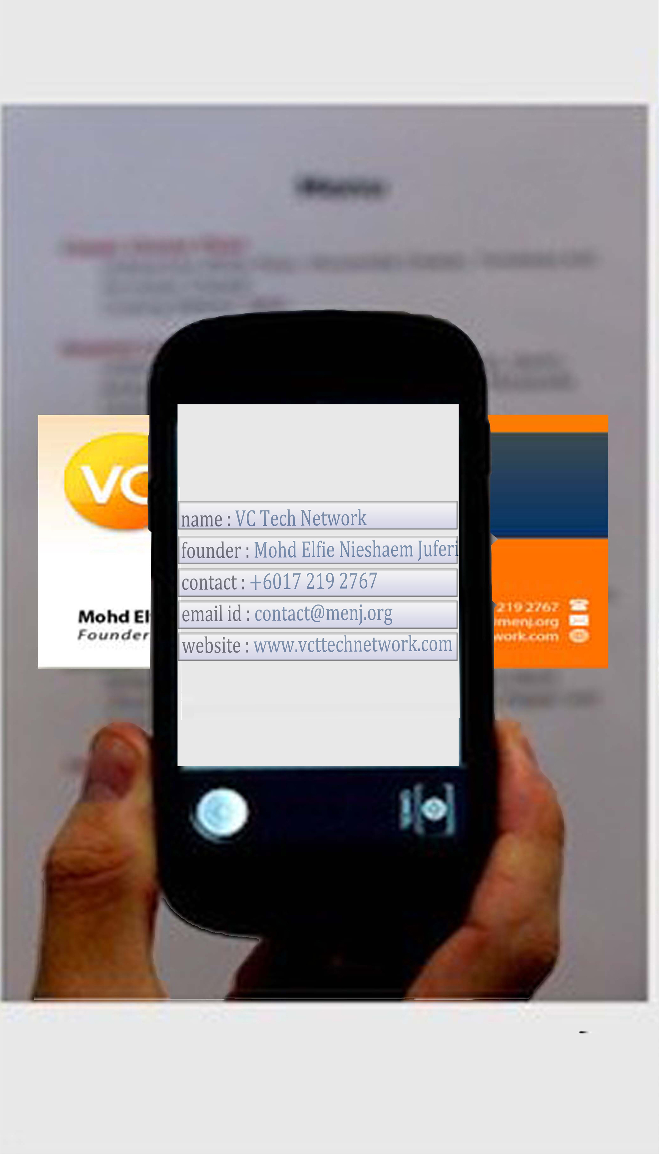
Fig B.6
The image is captured, then user click extract button to extract the name, number ,email id and address and provide an option to save it to the contact.

REFERENCES

[1] “The Busy Coder's Guide to Android Development” Mark L. Murphy
[2]Schildt “Java2 Complete Reference” 3th edition Tata McGraw Hill
[3] Brett McLaughlin “Java & XML data binding” O'Reilly Media, Inc.
[4] Search Engine: www.google.com
[5] SDK Downloads: http://developer.android.com/sdk/index.html
[6] Installation: http://developer.android.com/sdk/installing.html
[7] Explanations: www.wikipedia.org
[8]Eclipse Downloads: http://www.eclipse.org/downloads/
[9JDK:http://www.oracle.com/technetwork/java/javase/downloads/index.html
[10] Java: http://java.com/en/download/index.jsp
[11] ADT Plugin: http://developer.android.com/sdk/eclipse

